Health Connect
Full Stack Development with MERN - Functional Specification Document
Date | 18th June 2026
Team Members
Project Name | Health Connect
Document Version | 1.0.0

1. Introduction
Health Connect is a comprehensive digital healthcare management platform designed for the Indian healthcare context. Built with Node.js, Express, MongoDB, and React with Bootstrap 5, it connects patients and doctors through a unified web workspace. The primary goal is to address fragmented medical records and inefficient clinic booking processes.

2. Project Overview
Purpose:
To provide patients with a secure medical record locker and a dynamic prescription progress tracker, while allowing doctors to manage their clinical schedules and write digital prescriptions. Admins verify credentials and view metrics.
Key Features:
• Auth & Identity: Role-based access control (Patient, Doctor, Admin) with JWT verification and Indian phone formatting checks.
• Medical Record Locker: Multer-based uploading for diagnostic reports (PDF/JPG/PNG) rendered on a chronological timeline.
• Prescription Progress Tracker: Patients toggle checkboxes for active medications, updating a progress completion percentage bar.
• Doctor Scheduling: Real-time availability slot selection and reservation with fees represented in INR (₹).
• Admin Panel: Approve pending doctors and monitor platform analytics through visual charts.

3. Architecture
The system uses a decoupled client-server architecture:
• Frontend: Built with React, Vite, and Bootstrap 5. Employs Axios for async API communication and React Router for dashboard routing.
• Backend: Node.js and Express server. Employs custom JWT guards, Multer middleware for report handling, and Bcrypt encryption.
• Database: MongoDB Atlas cloud instance using Mongoose ODM to model patients, doctors, slots, and appointments.

4. Setup Instructions
Prerequisites: Node.js (v18+), npm (v9+), and access to a MongoDB instance (cloud Atlas or local server).
Installation Steps:
1. Clone the project files to your directory.
2. Navigate to the root workspace and install all dependencies: `npm run install-all`.
3. Populate backend environment variables in `backend/.env`:
PORT=5000
MONGODB_URI=mongodb+srv://...
JWT_SECRET=...
NODE_ENV=development
4. Seed the database with default accounts: `cd backend` -> `node seeder.js`.

5. Folder Structure
Root Coordination:
• backend/ - API models, controllers, and middlewares.
• frontend/ - React UI source files.
• package.json - Coordinates workspace dependencies.
Backend Detail:
• config/db.js - MongoDB Connection script.
• controllers/ - Logic for Auth, Doctor, Booking, Locker, Prescriptions.
• middleware/ - JWT authentication validation & Multer upload middleware.
• models/ - Schemas (User, Doctor, Appointment, MedicalRecord, Prescription, FollowUp).
Frontend Detail:
• src/pages/ - Dashboard views separated into admin, doctor, patient, and public routes.
• src/components/ - Reusable components (Navbar, Sidebar, ProgressBars).
• src/context/ - Global states (AuthContext).

6. Running the Application
To start both the frontend and backend servers, run the following command in the project root directory:
npm run dev
Alternatively, start them separately:
• Backend API: `cd backend` -> `npm run dev` (Server listens on http://localhost:5000)
• Frontend UI: `cd frontend` -> `npm run dev` (Vite UI runs on http://localhost:5173)

7. API Documentation
• POST /api/auth/register - Register a patient/doctor (Body: name, email, password, phone, role).
• POST /api/auth/login - User login, returns JWT token.
• GET /api/doctors - Fetch approved doctors list.
• POST /api/appointments/book - Patient reserves appointment slot.
• POST /api/medical-records/upload - Multer upload for reports.
• POST /api/prescriptions/new - Doctor writes diagnostic medications.
• PUT /api/prescriptions/:id/medication - Patient checks medication taken status.

8. Authentication
Authentication is implemented using JWT (JSON Web Tokens). During login, the server generates a token containing the user id and role, signed with a secret key. The client stores this token in local storage and includes it in the Authorization header for subsequent API calls. Express auth middleware decodes the token, validating roles.

9. User Interface & Screenshots

• Login Page
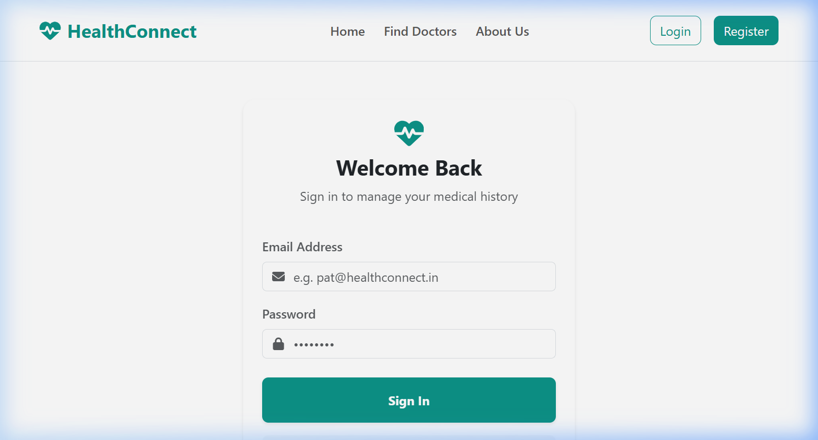
Figure: Login Page - The public access portal supporting role-based credentials validation.

• Patient Dashboard
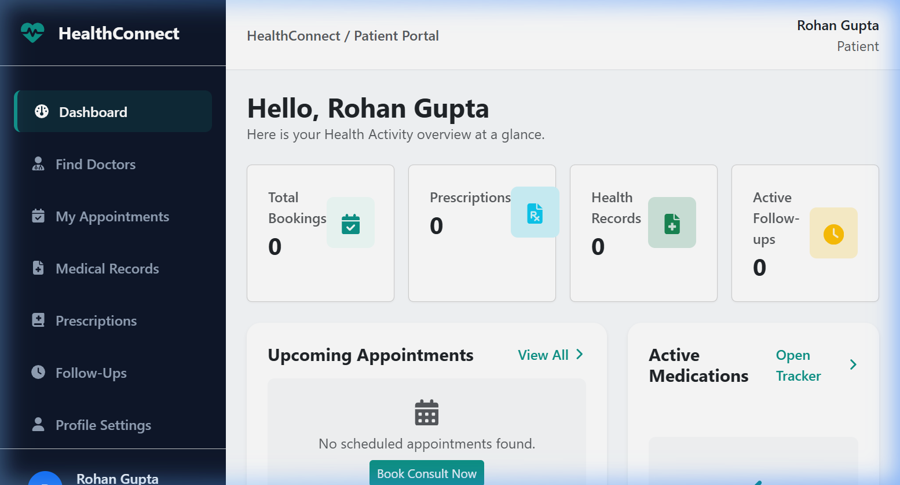
Figure: Patient Dashboard - Patient portal showcasing upcoming consults and quick reminders.

• Patient Prescriptions Tracker
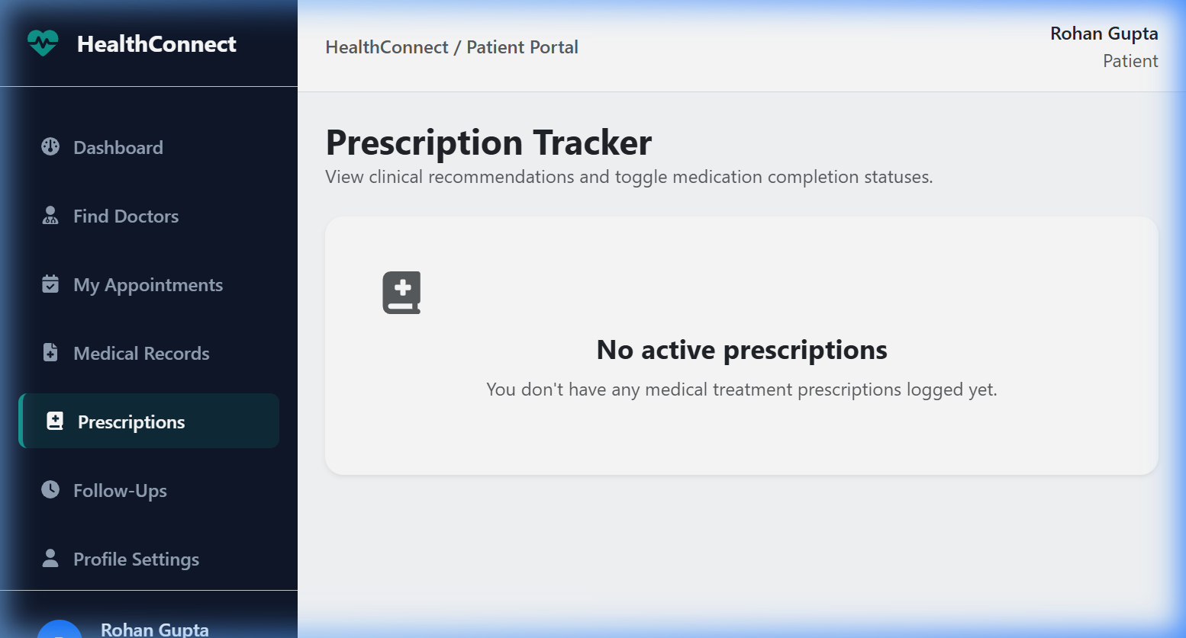
Figure: Patient Prescriptions Tracker - Adherence tracking showing checkable medications and real-time compliance progress bars.

• Medical Records Locker & Timeline
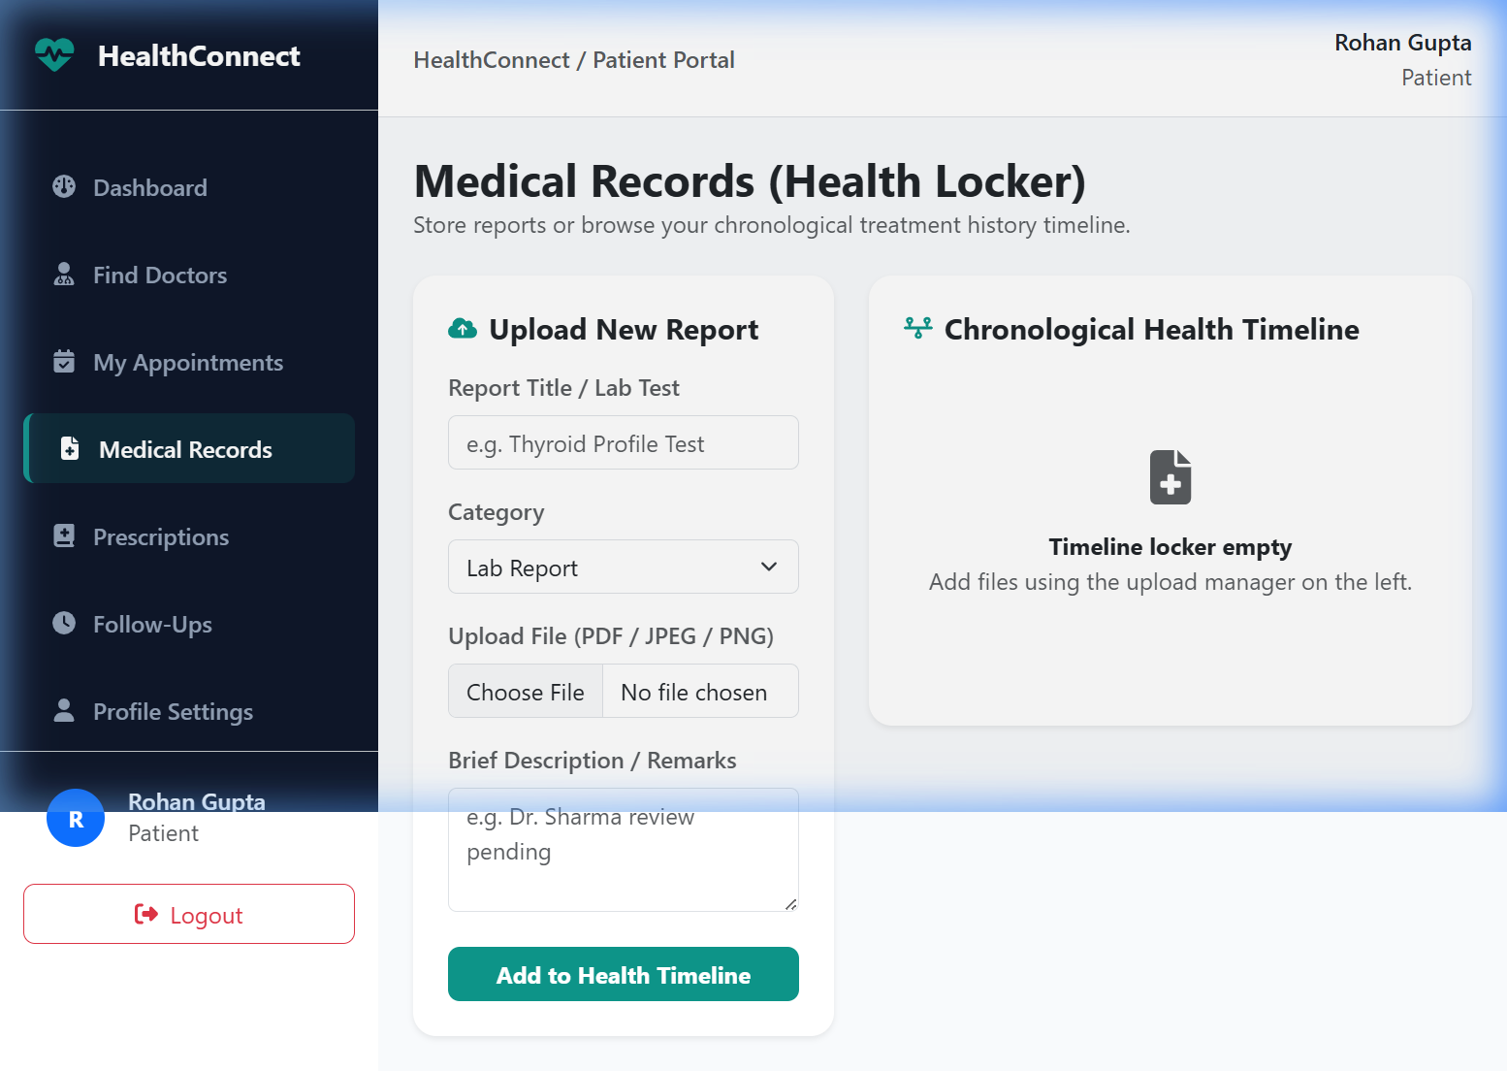
Figure: Medical Records Locker & Timeline - Secure document uploading and sequential visualization of the patient health history.

• Doctor Dashboard
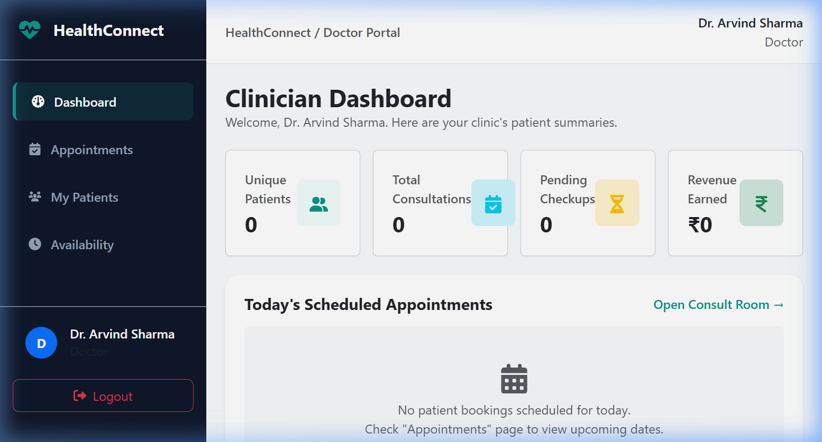
Figure: Doctor Dashboard - Clinical workspace where doctors view pending slots, queue consults, and write prescriptions.

• Admin Dashboard
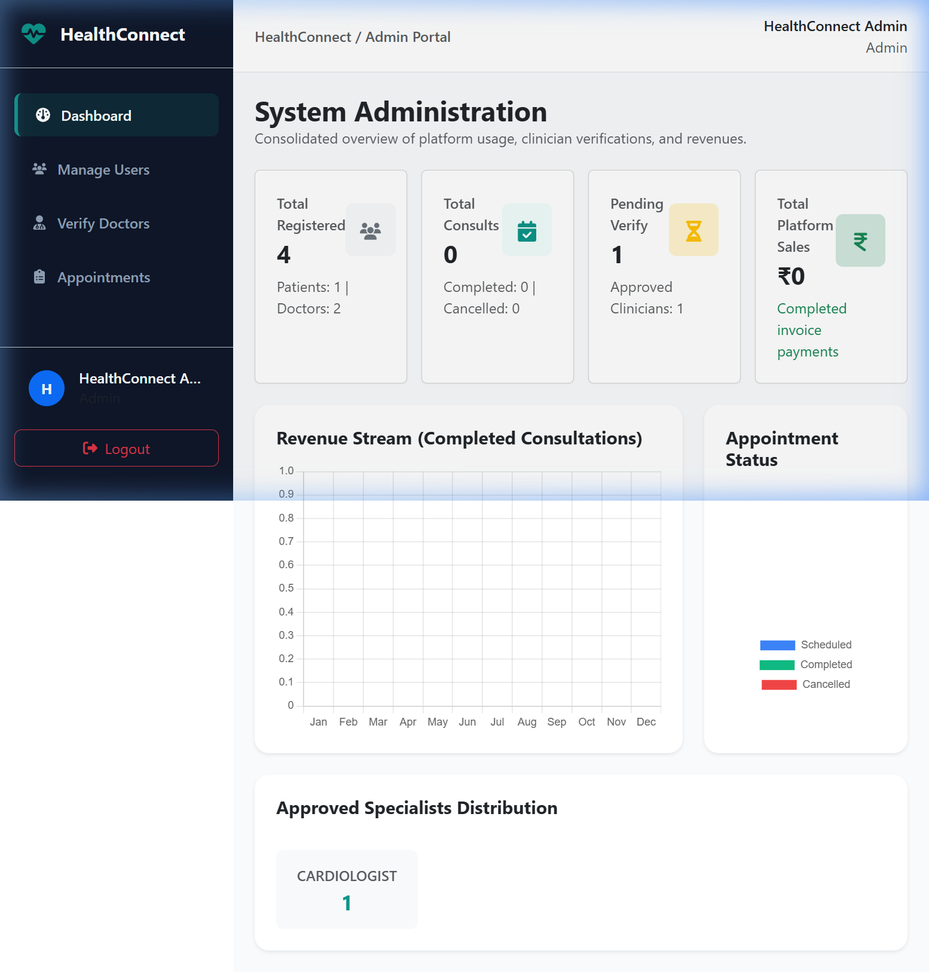
Figure: Admin Dashboard - Platform control desk compiling specialization charts and earnings metrics via Chart.js.

• Doctor Verification (Admin)
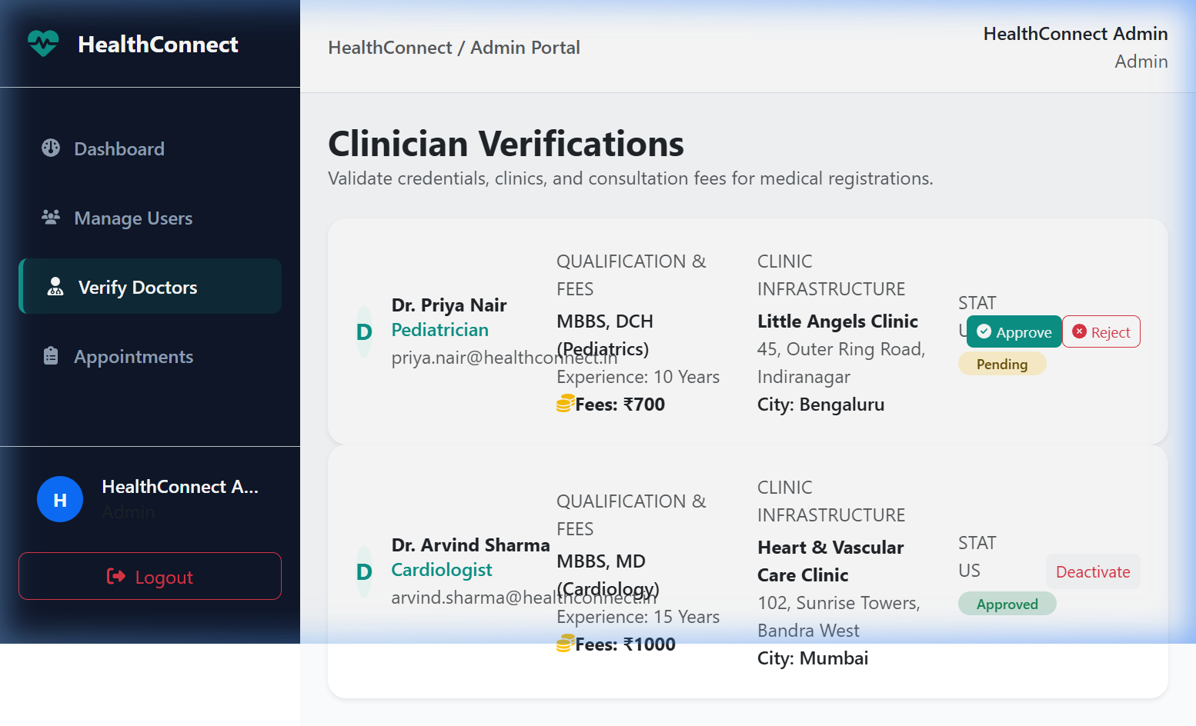
Figure: Doctor Verification (Admin) - Verification portal where admins review doctor documents and verify clinic permissions.

10. Testing
Manual testing flows were performed for all core components:
• Registration test: Verifying regex checks on phone fields (+91 or 10-digit formats).
• Admin approval loop: Registering pediatrician Priya Nair (pending), logging in as Admin, clicking approve, verifying she is allowed to log in.
• Booking validation: Rohan booking slot on Arvind's calendar. Ensuring slot is marked unavailable for others.
• Timeline upload: Dragging/dropping lab report PDF. Verifying timeline refreshes and file loads in new browser tab.

11. Known Issues
• Minor React Router splice warnings on Splat route resolution (to be resolved in v7 upgrade).
• Local Multer file storage results in report loss if backend container restarts (recommended migration to cloud storage like AWS S3 or Cloudinary for production).

12. Future Enhancements
• Integrated Video Consultation: In-app video calls via WebRTC or Zoom API.
• Automated SMS Alerts: Sending medication reminders and scheduling updates via Twilio API.
• Indian ABHA Integration: Linking health lockers to the government-sponsored Ayushman Bharat Digital Mission (ABDM).
Figure: Technical Architecture Diagram (Light Theme)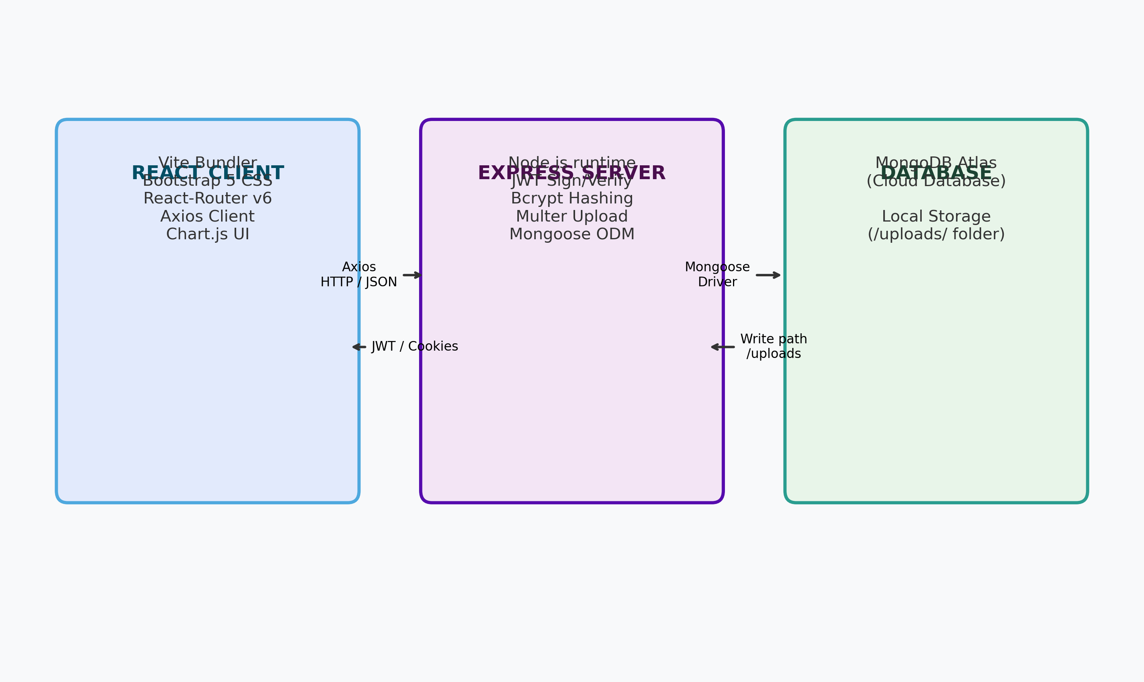
Figure: Solution Architecture Model (Light Theme)